Creating Excel Run Charts to analyze data
Control Chart
1. Gather and Format Your Data
Once you have the data gathered from your process, the first step in creating an Excel control chart is to ensure that it is correctly formatted. Your data set should be organized along a mean (average) – i.e. a target point that the data points are clustered around. If it’s not, your control chart will not be useful.
2. Do you need additional Data Columns ?
Often you will need to create the variables needed to create the plot from the data collected. Begin by thinking what you may need to do to calculate the data that is going to be reflected in the run chart. Usually Column A should be your time periods. Column B could be the data from your measure (possibly the numerator), column C maybe the denominator for the measure at that time period.
You may need to do some additional calculations to produce the data that you will plot. You should also calculate the center line (mean).

3. Create your run chart (run charts do not include confidence intervals)
What are you trying to do: Run charts are precursors to control charts. The y axis is the outcome metric of interest, the x-axis the relevant time frame, one plots the baseline and future data. Draw a center line (often median based on baseline data). Indicate a goal/target line. (see example)
Now that you have the framework for your run chart in your mind and your data ready, select the data and navigate to the Insert tab and locate the Chart group on the menu. Choose a Scatter chart type.
For the final step, you need to establish the field areas for your deviation. The chart may look complete, but it isn’t in the proper format just yet. Right-click a data point on center line and select Change Series Chart Type. When the menu opens, choose a line chart. Label the axis!
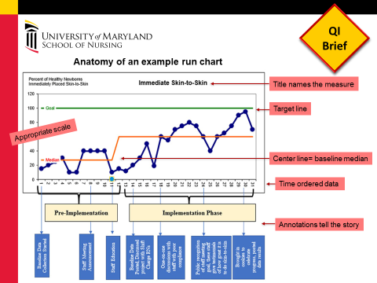
IHI Run Chart Video Part 1 (5:32)
http://www.ihi.org/education/IHIOpenSchool/resources/Pages/AudioandVideo/Whiteboard13.aspx
IHI Run Charts Video Part 2 (8:26)
http://www.ihi.org/education/IHIOpenSchool/resources/Pages/AudioandVideo/Whiteboard14.aspx

Control Chart
- Set your formula for your Average and Upper and Lower Limits
Here’s an example of the formulas. When done autofill the formulas down to the end of your data.
b). Create Your Excel Control Chart
Now that you have the framework for your Excel control chart set up and your data imported, select the data in columns B through F and navigate to the Insert tab and locate the Chart group on the menu. Choose a Scatter chart type.
For the final step, you need to establish the field areas for your deviation. The chart may look complete, but it isn’t in the proper format just yet. Right-click a data point on your Lower limit line and select Change Series Chart Type. When the menu opens, choose a line chart. Repeat this action for your “Upper” and “Average” data sets. Click OK to confirm and your Excel control chart will be complete.

You can add chart and axis titles and format the axes by clicking on the chart and clicking on ‘layout’ under ‘chart tools’ on the formatting ribbon.

