NURS310 COMPUTER BASICS Crossword Puzzle

**Across**

1. Type of software that allows users to dialogue, share, and network with other users

3. Virtual storage area for large databases

4. Where data, files and folders are stored on a computer

6. Acronym for the computers primary memory

11. Type of software that mediates between hardware and application programs

12. Network of networks

13. Interface that users can view information from a variety of sources

14. The main circuit board of the computer

16. Acronym for transaction and internet protocols

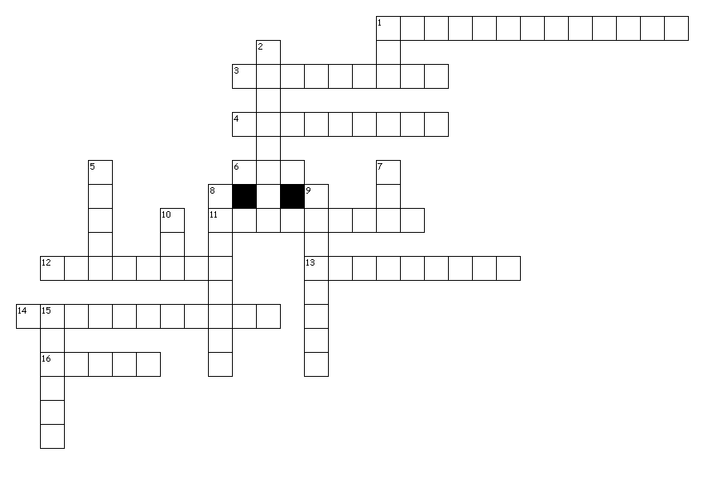

**Down**

1. Acronym for electronic circuitry that interprets and executes instructions

2. A collection of related data

5. Devices that sends data or commands to the processing unit

7. Acronym for network that connects devices over a relatively short distance

8. Set of instructions that tell the computer what to do

9. Physical artifacts of technology

10. Acronym for networks in different geographic areas

15. Processed data in an understandable and useable form