Below uses the example of a correlation of 0.79 and sample size=30 to plug in the EXCEL function.

**Calculate the exact significance of a Pearson correlation in MS Excel**

The correlation between variable1 and variable2 =0.79.

Inconveniently, this is not completely straightforward - Excel will not give us the exact p-value for any value of r. However, it will give the exact p-value for any value of t, and it’s not too hard to convert r to t.

1. Calculate t, The formula you need is this one:

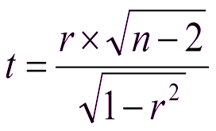

So, we have a value of r = 0.79, and N = 30.

We can use Excel to turn the r into t, so in the Excel sheet we type:

=0.79*SQRT(30-2)/SQRT(1-0.79^2) =6.8182

This gives a value of t = 6.8182.

1. We then use the **tdist( )** function in EXCEL to find the associated p. We need to tell Excel three things. First, the value of t, second, the degrees of freedom, which are equal to N – 2 = 28, and third, the number of tails – either 1 or 2, and we always use 2 tails.

So in the Excel sheet type:

=TDIST(6.8182, 28, 2) =2.08703E-07

Which gives a result of p <.001.