Steps on how to open a datafile in IS

Start by logging into Intellectus Statistics (assuming you already have purchase complete)
Uploading data

In projects screen click on create project/upload dataset
Name your project and then hit continue
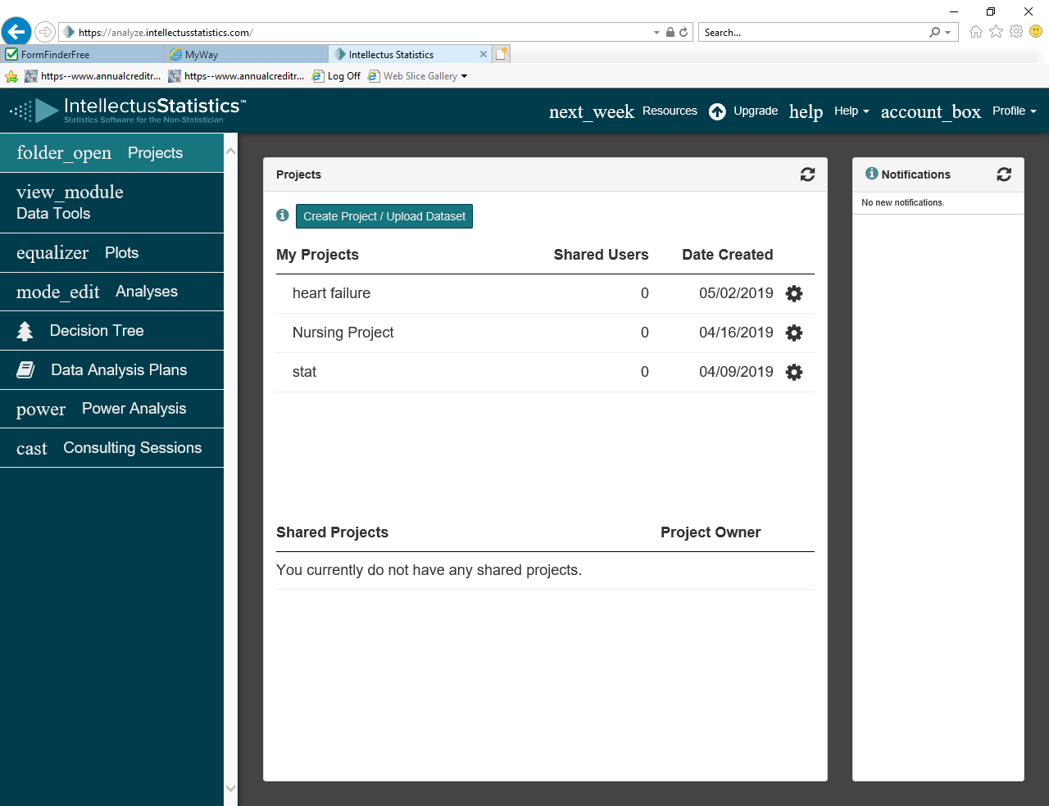

A select the file type screen will appear
Since we are using excel datafiles in this class select the file type .xlsx
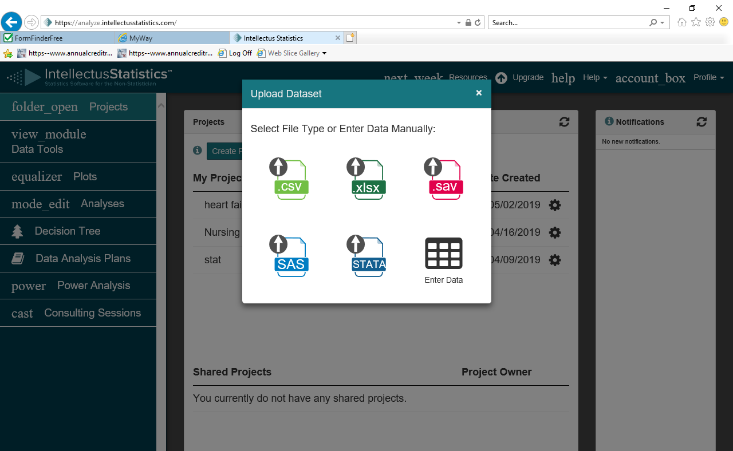

Once connected to the file a screen will appear to verify your levels of measurement
It is very important to verify and adjust where necessary because the variables need to be correctly defined in order to use them in particular data anlaysis procedures.
Change levels by using the ‘down’ symbol and select the proper level of measurement from choices
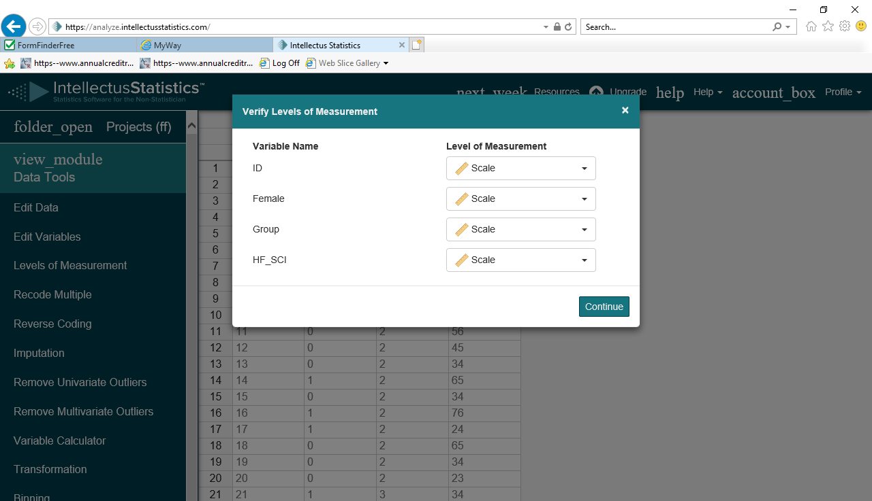

From here your data is set up to run various analyses.

