**Steps to running t-tests in EXCEL** 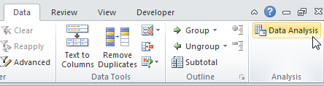

**Standard t test**

1. Excel wants your data in two columns, one for each group or

|  |  |
| --- | --- |
| control | experiment |
| 56 | 41 |
| 41 | 47 |
| 27 | 38 |
| 44 | 46 |
| 25 | 37 |
| 35 | 33 |
| 29 | 45 |
| 31 | 42 |

treatment level. Give each column a heading. See example to the right.

1. On the data tab select **Data Analysis…**

and choose “**tTest:TwoSample Assuming Equal Variances**.” OK.

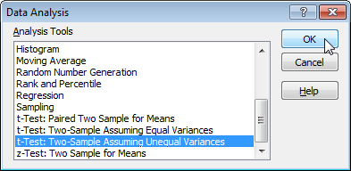

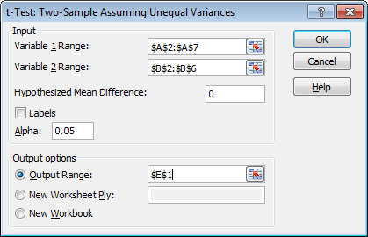

1. Excel asks you to specify the range of cells containing the data.

Click the first icon, then highlight your first column of cells, *including its heading.* Enter.

Now click the second icon, and highlight your second column, including the heading. Enter.

1. Check the **Labels** box, so Excel knows you included headings atop each column. OK.
2. Excel whips out an Output table. You can quickly resize the columns by double clicking

up top between the A & B, between the B & C, and between the C & D.

There’s lots of info here, but all you’re really after are those P values.

Use the **twotailed pvalue** if your original hypothesis predicted that the means would merely be

different. Usually, however, you will have specifically predicted one mean higher than the other (< or >). In that case (and if in fact the means match your prediction of greater than or less than), go with the smaller **onetailed pvalue**. lf t Stat < -t Critical two-tail or t Stat > t Critical two-tail, we reject the null hypothesis

**Paired t test**

1. You can use the powerful paired ttest if (and only if) your study employed a “paired”

design in which a pair of data were collected in parallel from each individual, “mirror

|  |  |
| --- | --- |
| pre-test | post test |
| 34 | 38 |
| 41 | 39 |
| 26 | 38 |
| 44 | 49 |
| 29 | 30 |
| 33 | 31 |
| 37 | 49 |
| 25 | 36 |

image” style …such as left versus right or before versus after.

Here again, Excel wants your data in two columns, one for each variable.

Give each column a heading.

2. On the data tab select ***Data Analysis…***

and choose “**tTest: Paired Two Sample for Means**.” OK.

3. Excel asks you to specify the range of cells containing the data. Click the first

icon, then highlight your first column of cells, *including its heading.* Enter.

Now click the second icon, and highlight your second column, including the heading.

4. Check the **Labels** box, so Excel knows you included headings atop each column.

5. Excel whips out an Output table. You can quickly resize the columns by doubleclicking

up top between the A & B, between the B & C, and between the C & D. There’s lots of info here, but all you’re really after are those Pvalues.

Use the **twotailed pvalue** if your original hypothesis predicted that the means would merely be different.

Usually, however, you will have specifically predicted one mean higher than the other (< or >). In that case (and if in fact the means match your prediction of greater than or less than), go with the smaller

**onetailed pvalue**.

Attention Mac Users:

This video was shared by a student and may be helpful for Mac users

t test video <https://www.youtube.com/watch?v=cMvrgYtkgzQ>