**Steps to running a correlation in EXCEL**

**Step 1: Create a Scatterplot of the Data to determine if there appears to be a linear relationship**



1. Select the data for which you want to create the scatterplot

2. Go to "Insert" in the menu on top

3. Go to the chart section with the various plots (middle of the menu)

4. Click on the icon with the various dots on it (scatter)

5. Once your figure appears notice you have new a sub menu

6. In the chart layout area choose the scatter plot you prefer (chart type 9 (one with fx) will also print a regression line formula).

**Step 2: Calculate the Pearson correlation coefficient**

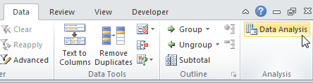

1. On the Data tab, click Data Analysis.
2. Select Correlation and click OK.

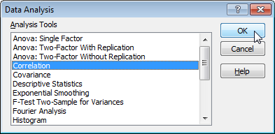

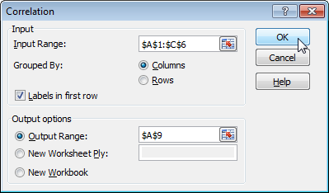

1. Select the range of cell and insert as the Input Range

4. Check Labels in first row if among the range of cells.

5. Select cells for the Output Range.

6. Click OK.