Steps to running correlation in IS

Scatterplot
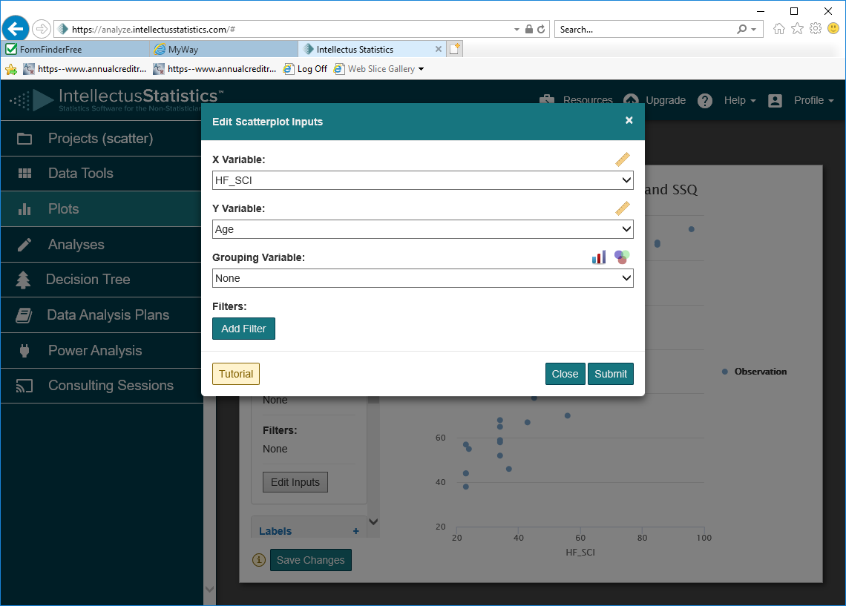
- Select Plots and choose scatterplot
- Click on down arrow to choose the x variable,
- repeat for y variable
- Hit submit to see plot

If hit the tutorial button on the bottom left will see
a menu ..choose download plot for instruction of
how to export your plot to your write up.

Correlation

- Select analysis ...
- Choose Correlations....then Pearson correlation
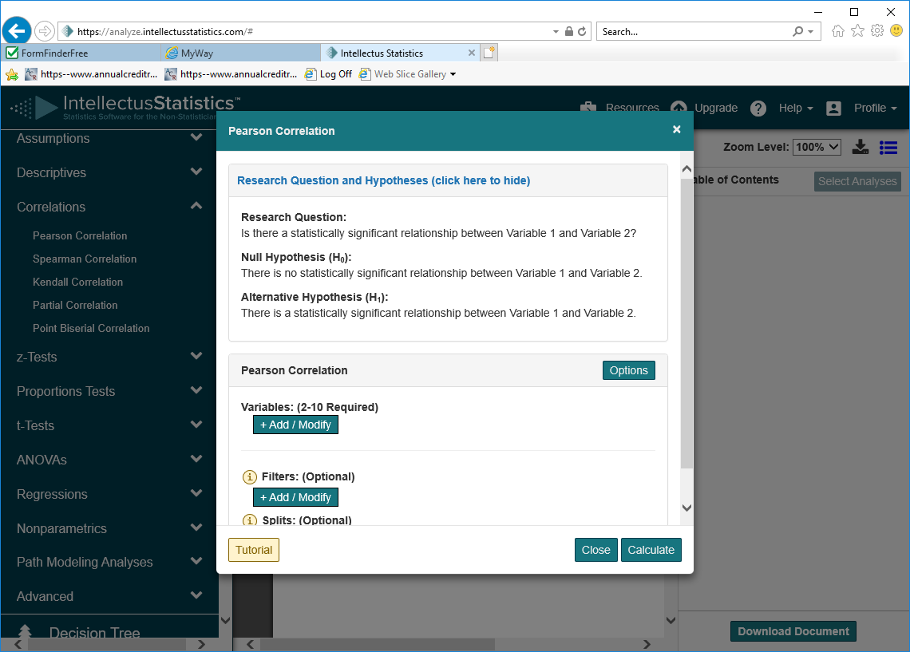
- Identify your variables
When ready click on the +Add/Modify
Choose the variables (hit add variable button)
Check that hypothesis is correct for what you want to do.
8.calculate
- View the raw output view (choose button on top)
- View the results.
- View the document view to see example of write up

A scatter plot can also be produced in the correlation section by selecting ‘options’ on the page you select the variables.
In the area labeled check for linearity choose the down arrow to enable the feature.

