The effect of antenatal care follow-up on neonatal mortality (Wondemagegan AT, et al., 2018)
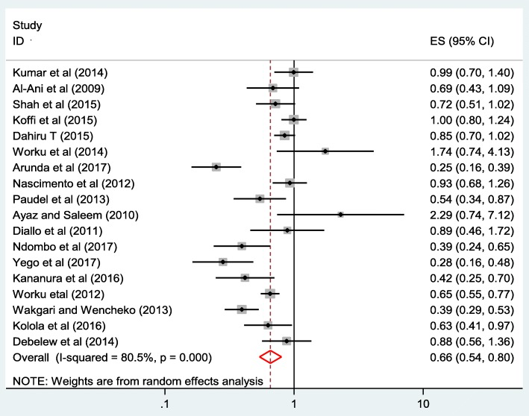

- What kind of graphic is this?
- How many studies are represented in this figure?
- What do the boxes and bars represent?
- How many of the studies shown found a significant positive effect size?
- How many of the studies shown found a significant negative effect size?
- What is the pooled effect size of neonatal death among mothers who had antenatal visits compared to births to mothers without any antenatal visits?
- By what percentage does this review find that Antenatal visits can decrease neonatal mortality?

