A Pearson correlation analysis was conducted among Age, HF_SCI, and SSQ using IS software.
Assumptions: Normality: Shapiro-Wilk tests were conducted to determine whether the distributions of Age, HF_SCI, and SSQ were significantly different from a normal distribution. The following variables had distributions which significantly differed from normality based on an alpha of .05: HF_SCI (W = 0.91, p = .018) and SSQ (W = 0.93, p = .044). The following variables had distributions which did not significantly differ from normality based on an alpha of .05: Age (W = 0.95, p = .161). Note that the deviation from normal distribution may be due to limited sample size.
Linearity. A Pearson correlation requires that the relationship between each pair of variables is linear. This assumption is violated if there is curvature among the points on the scatterplot between any pair of variables. Figure 1 presents the scatterplot of the correlation. A regression line has been added to assist the interpretation.
Figure 1
Scatterplots with the regression line added for Age and HF_SCI (left), Age and SSQ (right)
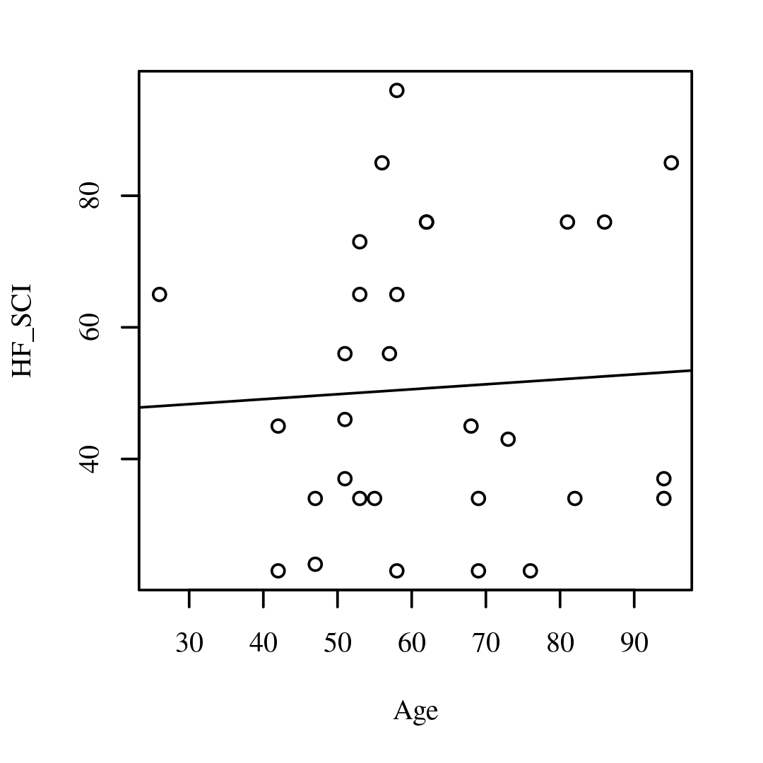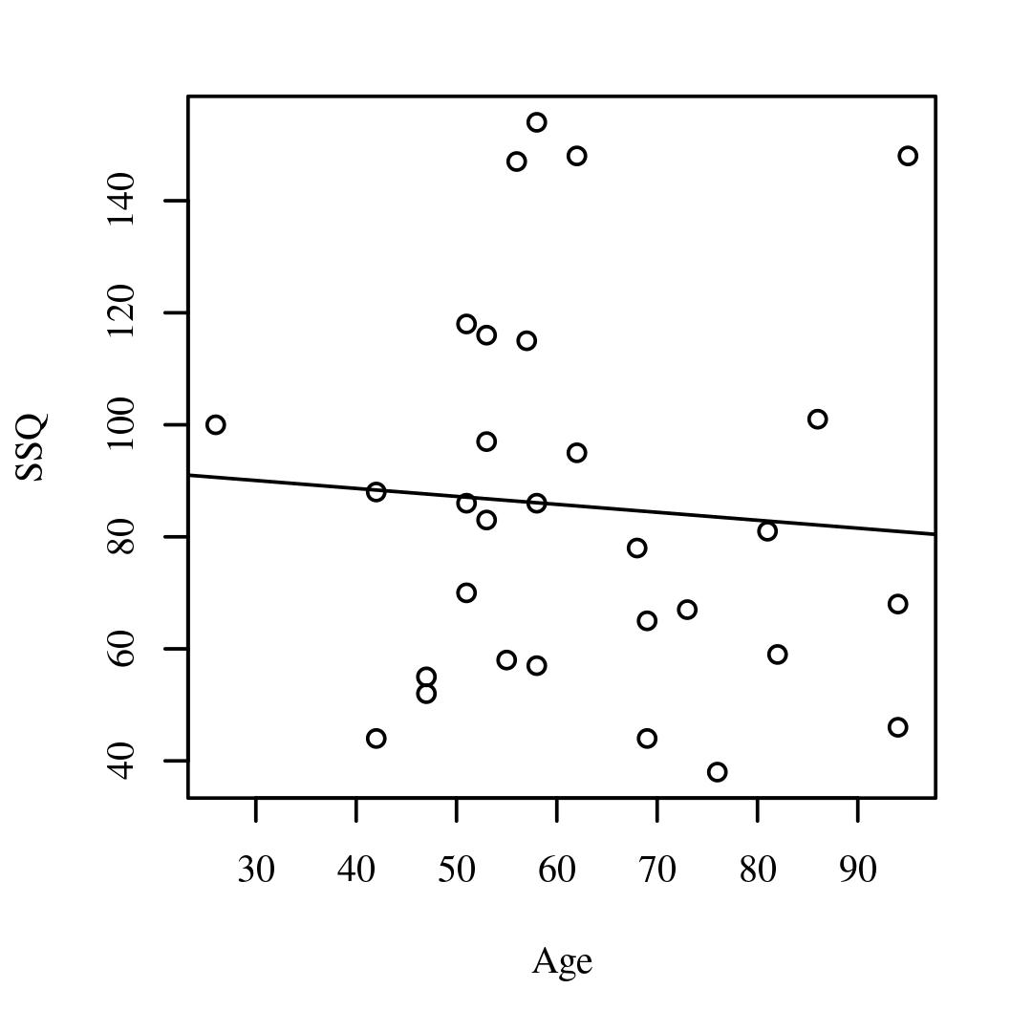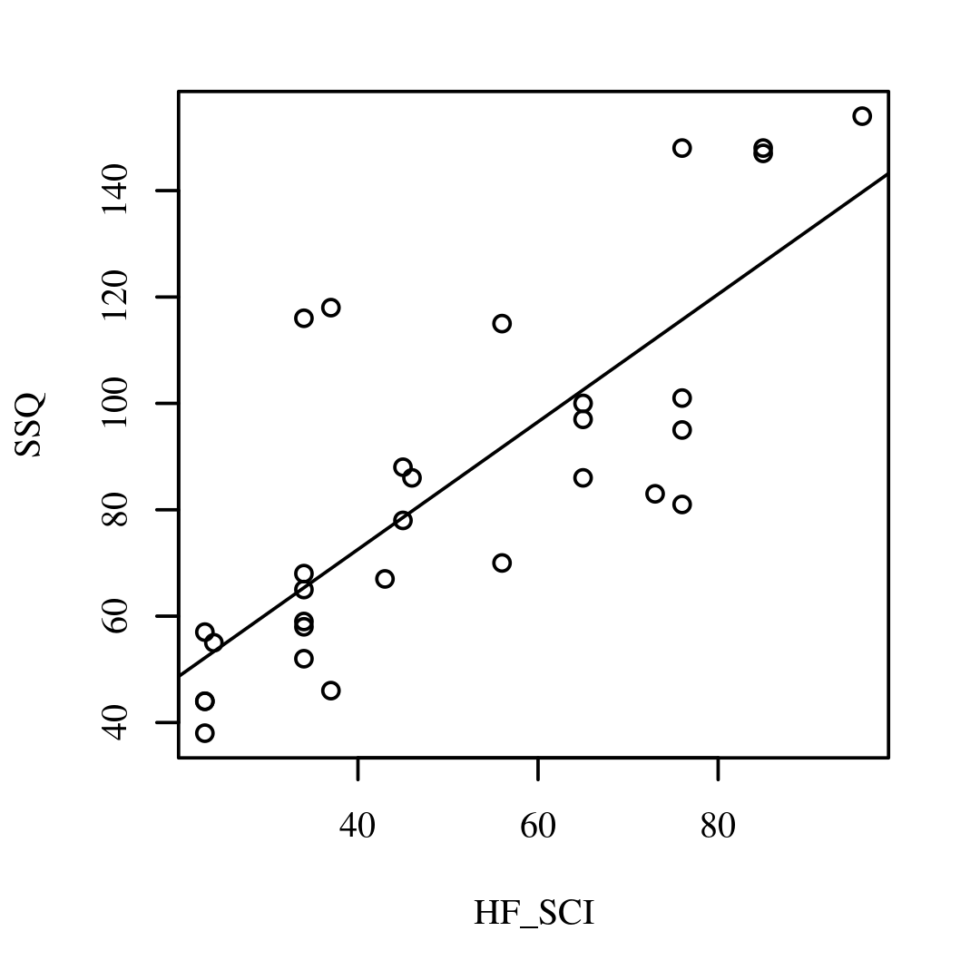
The result of the correlations was examined based on an alpha value of .05. A significant positive correlation was observed between HF_SCI and SSQ, with a correlation of r=.79, indicating a large effect size (p < .001, 95.00% CI = [.60, .89]). This suggests that as HF_SCI increases, SSQ tends to increase. No other significant correlations were found. Table 6 and Table 7 present the results of the correlations.
Table 1 Pearson Correlation Matrix Among Age, HF_SCI, and SSQ
Variable | 1 | 2 | 3
1. Age | -
2. HF_SCI | .06 | -
3. SSQ | -.07 | .79* | -
Note. *p < .05.

Table 2 Pearson Correlation Results Among Age, HF_SCI, and SSQ
Combination | r | 95.00% CI | n | p
Age-HF_SCI | .06 | [-.31, .41] | 30 | 1.000
Age-SSQ | -.07 | [-.42, .30] | 30 | 1.000
HF_SCI-SSQ | .79 | [.60, .89] | 30 | < .001

