Implications for Integrating Environmental Health into Professional Nursing
Please use this as a tool in formulating your discussion of the nursing implications for your topic. Note that although the implications are divided into four categories they are not mutually exclusive. As essential components of the role of the professional nurse and the nursing profession, there is overlap in and an interrelationship among these actions
Implications for Professional Nursing Practice: This is related to what actions you, as a nurse, can take in your professional role as a nurse related specifically to your issue. This includes care for patients, clients, families, and the public/communities. For ideas, refer to the actions on Minnesota Public Health Intervention Wheel:
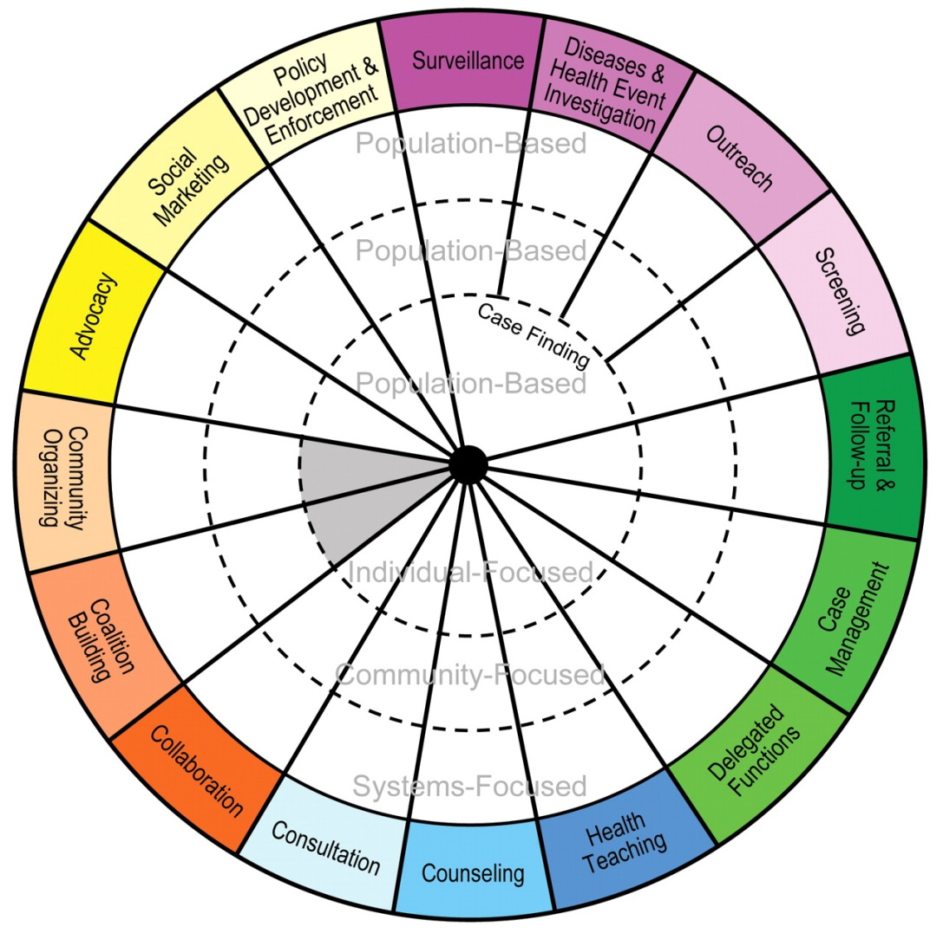
http://www.health.state.mn.us/divs/opi/cd/phn/wheel.html
Implications for Professional Nursing Education: This pertains to how you would educate yourself and other nurses and health professionals about the issue. (e.g. curriculum, webinars, conferences, summer institutes, posters, articles, etc) Include in your discussion what the overall learning objectives of your content would be, not the specific facts or details.
Implications for Policy and Professional Advocacy: Discuss how you would bring the voice of nursing to local, state, and national environmental health policy and advocacy initiatives. Identify what nursing or health professional organizations and/or environmental organizations are working on this issue. Identify and explore and existing regulations, pending legislation or institution policies related to the issue. What political or institutional actions could you and other nurses take to address the issue? (e.g. sign on letters, provide testimony, educate legislators, legislative visits, implement workplace policy changes, create “Green teams”, write letters to the editor, hold community meetings, vote, participate in identified professional/environmental organization activities) Also consider and describe how to engage nurses in policy and advocacy who are not currently engaged.
Implications for Scientific Research: There are two different levels of research. One level relates to existing body of knowledge and the other is related to conducting research activities. Consider and describe the state of the existing evidence. Is the level of evidence such that you would be able to base nursing practice, nursing education, and/or policy/advocacy actions upon? Describe the research gaps and identify ways in which nurses can contribute to the knowledge base (e.g. participate in quality improvement projects, participate in a research study as a subject or investigator, and/or ideas for the design of a research study.) Depending on your skill level and comfort with research activities, what could you participate in?

